Best for Baby

The Neuroscience of Birth

With Dr. Nils Bergman
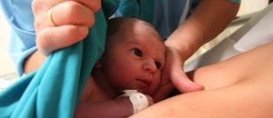Friday, April 3rd, 2020
9 a.m. to 5 p.m.
Lake Elmo Inn
3442 Lake Elmo Ave N.
Lake Elmo, MN 55042
Cost: $180
This presentation will share the scientific evidence for maternal-infant skin-to-skin contact and the case for zero separation. We will also discuss practical ways to provide a neurologically supportive labor and delivery unit and NICU environment
Guest Speaker:
Dr. Nils Bergman, a Swedish specialist in perinatal neuroscience, now also called nurturescience, is one of the founders of the Kangaroo Mother Care (KMC) movement and a promoter of skin-to-skin contact and early breastfeeding
https://mcclarkconsulting.com/best-for-baby/

