Finding your way to the conference room at Lambeau Field:
Please arrive at the American Family Insurance Gate on the stadium’s east side and take the escalators to the 2nd floor. They will then join up with another set of escalators just across the cat walk to take them to the 4th floor club level. Once on the 4th floor, there will be event signage to direct your guests to your event space. There is a map attached as well to send to the bus driver and other guests.

Directions to Lambeau Field Parking Map:
Exit Number 167 Lombardi Avenue off Highway 41 (North & South)
Coming on I-43 North take 172 West to Highway 41 North
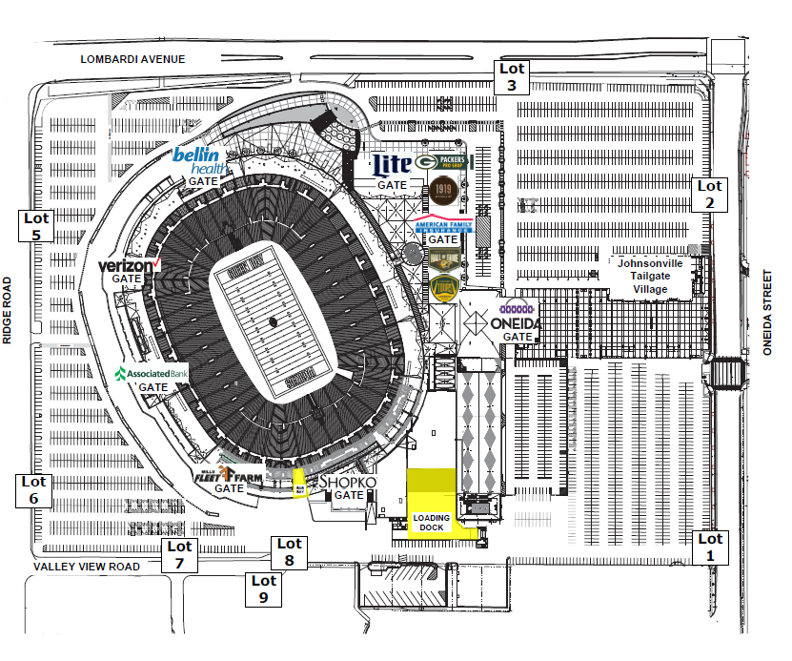

Building a Breastfeeding Legacy Schedule & Session Objectives
Pregame: Registration, breakfast snacks & welcome! (7:15 - 8:05)
Kickoff: The Ingredients of Human Milk - Dr. Jen Thomas (8:05 - 9:05)
- Discuss the composition of human milk and the changes in ingredients over the course of lactation
- Explain the structure and function of human milk oligosaccharides
- Explore the various bioactive proteins found in human milk
- Discover the dual nature of the ingredients in human milk as they provide nutrition and protection for the infant.
Time Out: Break (9:05 - 9:15)
1st Quarter: High Five for Success: Helping Moms Prepare for their Hospital Experience - Cathy Carothers (9:15 - 10:15)
- Identify at least 3 reasons for supporting mother – baby togetherness in the first hour after birth
- Name three ways skin to skin care (SSC) impacts feeding outcomes
- Identify two ways to support maternal and infant rooming – in during the hospital stay
- List two ways to help parents learn the needs of their newborn.

Time Out: Break (10:15 - 10:25)
2nd Quarter: The Sensory Experience of the Newborn - Dr. Thomas (10:25 - 11:25)
- Describe the development of the newborn’s hearing, sense of smell, vision, and perception of taste
- Relate the development of these sensory skills to their role in breastfeeding
- Discuss breastfeeding as it relates to a newborn’s emotional development
- Explain the role of touch as it relates to newborn brain development
Time Out: Wisconsin Coffective - Jen Ortner (11:30 - noon)
Half Time: Lunch & Network (noon — 1:10)
3rd Quarter: Working Together: Communicating With Physicians about Breastfeeding
- Dr. Thomas (1:10 - 2:10)
- Understand why physicians should be knowledgeable about breastfeeding
- Describe what we know about physician knowledge and attitudes about breastfeeding
- Describe how physicians learn and potential roadblocks
4th Quarter: Making it Work: Supporting Nursing Moms at Work
Cathy Carothers (2:15 - 3:15)
- Identify at least three major barriers to breastfeeding among employed women.
- Identify at least two solutions for maintaining milk production after returning to work.
- Name at least two ways to assist mothers in preparing for their return to work.

Time Out: Snack (3:15 - 3:30)
Post-Game: The Time is Right: Seize the Moment!
Cathy Carothers (3:30 - 4:30)
- Identify at least three national or state initiatives in each of the following areas that can improve breastfeeding support for new families: health care, government, legislation, and employment/child care.
- Identify at least two opportunities for building on national initiatives to support breastfeeding families.

